Student’s name
Professor’s name
Institution
Date
Long-run effects of pandemics
Introduction
This particular submission endeavours to achieve its objectives by providing an in-depth analysis of the more extended run consequences of a pandemic. Not only does this presentation give a review on the long term effects of the epidemic, but also provides additional info on the possible data that the article might have missed. This article was put down following the drastic impacts of COVID 19 on various individuals across the globe. Furthermore, the author of the report claims that most of the researches conducted on the COVID 19 pandemic have mostly focused on the short terms effects, rather than the long term effects of the epidemic ( Jorda et al.). A pandemic refers to an outbreak of a disease. The disease spreads across several places and therefore results in quite a several large losses. It is to submit that the short term effects pandemics have also hit hard across different nations. This particular article also sorts to provide possible suggestions of how the epidemics have affected various sectors of government.
I am of the view that the article should have dwelled on tourism as it has always been most affected by most pandemics. For instance, when epidemics occur, countries shut down their borders, and this prevents visitors from accessing the land. The most affected areas include both international and domestic tourism.
According to the United Nations World Tourism Organization (UNWTO), tourism was a major reason for the rapid spread of the virus as the carriers travelled in the form of tourists from highly infested states to states that still did not have the virus. The travel ban in most countries has, therefore been a measure put across by most countries to control the spread of the virus. The ban has however been a double-sword because as much as it controls the spread of the virus, it has inhibited major sectors in the world economy such as tourism resulting from measures put in place such as grounding of airlines and closing of hotels. The UNWTO confirmed that over ten years, 2010 to date, the world has experienced a massive rise in international tourism. However, since the virus started, tourism recorded a massive drop from 2019 with 2020 being a mere fraction of tourism recorded in the first quarter of 2019. Tourism in third world countries like Kenya has experienced breakthroughs and as so, been a very profitable sector to the country’s economy over the years. In 2018, for example, the sector grew by 3.9% from sh. 157.4 (1.574BUSD) billion tosh. 163.6 billion (1.6B USD) in 2019.The number of international visitors also increased by 0.4% to 20M in 2019. The remarkable growth of international travel was due to an increase in connectivity enabled by globalization, together with the rise of the middle class. Hotel bed-nights occupancy expanded by 6.3 per cent to 9,160.8 thousand during the same period. The boom in the tourism sector as a result of improved infrastructure, extensive promotion, and marketing as well as political stability and reduced civil unrest in the country Reports from the United Nations World Tourism Organization (UNWTO) suggest that the international tourists' numbers could fall by 60-80 per cent in 2020. This is largely due to the closing of borders by major travel destinations as a measure to curb the spread of the COVID-19. The domestic tourism has not been spared either due to the night curfews and lockdowns of the coastal cities that serve as a major destination for local tourists in third world countries like Kenya.
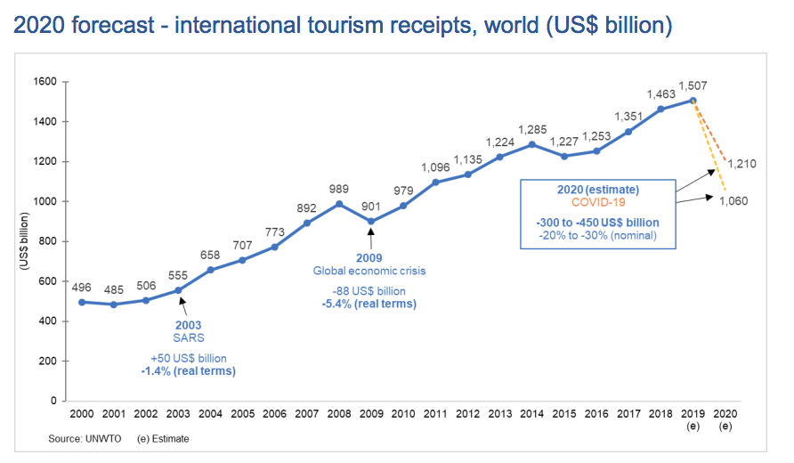

Conclusion
In conclusion, the information shared on the long term effects of world pandemics is useful. This is because nations can use it in a bid to curb the results of the epidemic. For example, a country with proper information regarding the pandemic is best fit to understand this scenario. However, I still believe that the authors of the article should have dwelled into tourism because tourism contributes a lot of revenue to most nations across the world.

Works cited
Jordà, Òscar, et al. “Longer-Run Economic Consequences of Pandemics.” Federal Reserve Bank of San Francisco, Working Paper Series, Mar. 2020, pp. 01–16, doi:10.24148/wp2020-09.

“UN World Tourism Organisation Says ‘Five to Seven Years’ of Growth Could Be Lost through COVID-19.” The Moodie Davitt Report, 27 Mar. 2020, www.moodiedavittreport.com/un-world-tourism-organisation-says-five-to-seven-years-of-growth-could.

‌

‌

